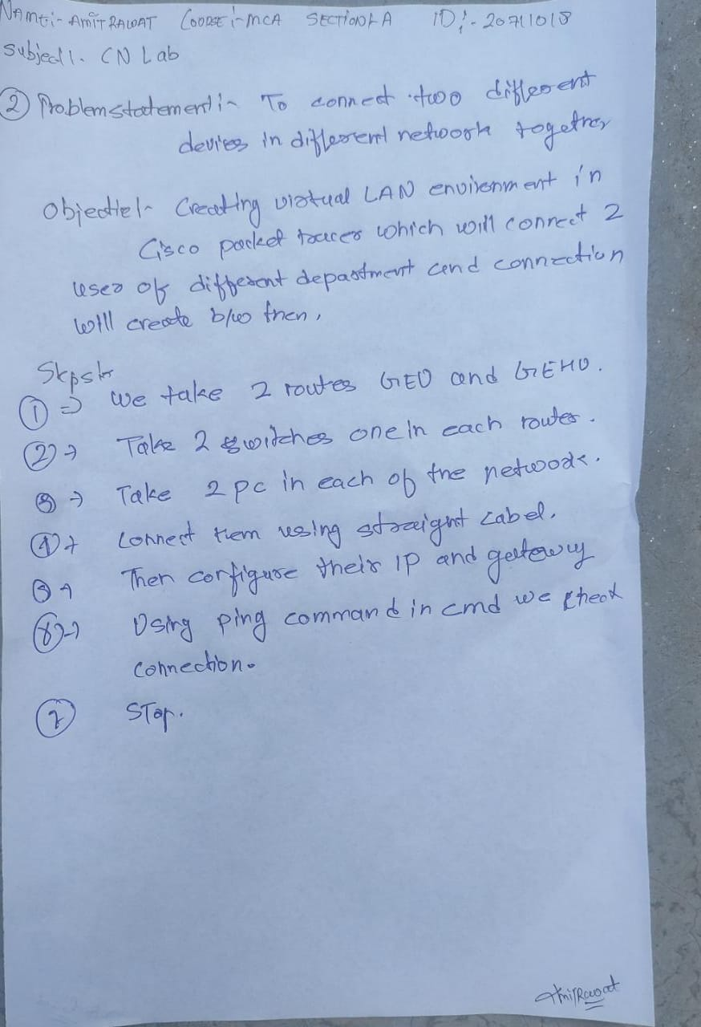

OUTPUT:_

